**URL:**

republik.io/whitepaper

**LANDING PAGE:**

Copy

Introducing RepubliK.

**The next-generation creator platform, powered by blockchain technology.**

A scalable ecosystem, built from the ground up, to equitably distribute value by giving everyone a stake in the economy.

Image (placeholder)

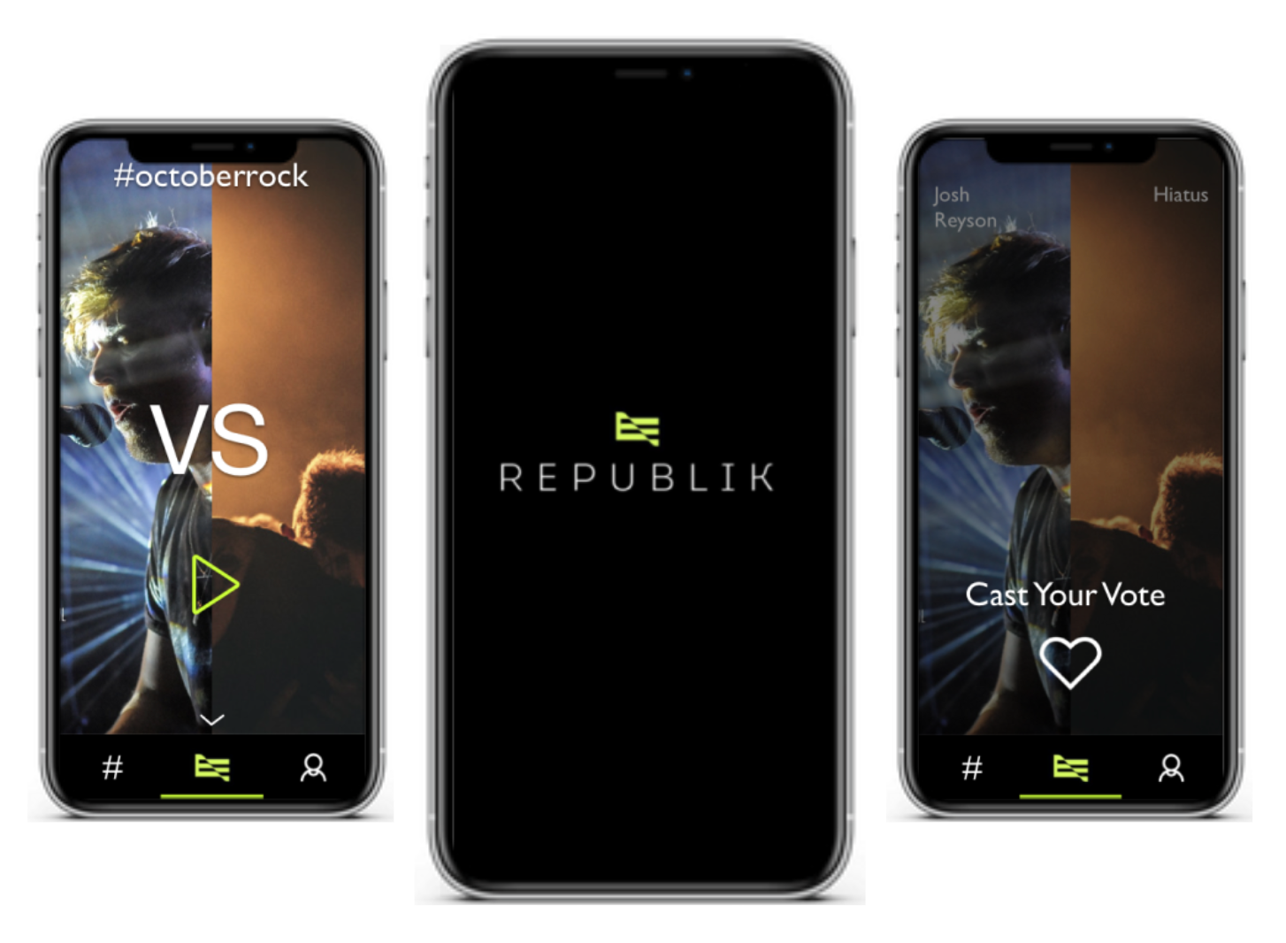

**MAIN SECTIONS:**

**The Creator Economy**

Problem

Opportunity

**RepubliK**

Introduction

The RAD Token

Exposure and Talent Discovery

Virtual Event Platform

Creator Journey

Keeping creators on platform

Market-entry

Distribution

Release Schedule

**Team**

Core Team

Advisors

**----------------------- The Creator Economy -------------------------**

**PROBLEM**

**The creator economy is broken**

The current ecosystem masquerades as a republic but is actually an oligopoly. We are led to believe that the system is fair and the share of the spoils equitable, but it is an illusion created by record labels, media companies, and social media platforms. In reality they dominate the economy for creative and artistic talent.

The end result is an inefficient market. The incumbents reap most of the rewards, shared with a slim apex of creative talent. A large majority of talent is never discovered, wasted, or diverted to more prosaic pursuits that pay the bills. There is no creative middle class.

This oligopoly also controls the investment in talent, and without avenues for direct investment the rest of us stay as consumers, not participants.

Imagine if even a small portion of the trillion dollars worth of Facebook’s market cap had been invested in the creators that fuel their platforms instead of being tied up in company equity. Imagine the impact that would have on content?

There have been many attempts to help creators generate more value, from direct donations (patreon, twitch) to services that help in the monetisation of content (Only Fans , Rally, various NFT generators).

However none of these address the fundamental issue of an oligopoly, resulting in the lack of early support for creators, poor monetisation efficiency and the absence of opportunities for mass participation in talent investment.

Solving these problems requires more than smart contracts, algorithmic automated market makers or unique virtual trinkets. It requires the creation of a new economy and an equitable ecosystem of products that support the creators and participants every step of the way.

**RepubliK will be the creative commons built from the ground up to equitably distribute value by giving everyone a stake in the economy.**

It will be an ecosystem of tools not rules, allowing each participant to define their own path free from the restrictions that exist today. A republic of Kin, where everyone is given an equal opportunity to succeed.

**OPPORTUNITY**

**The creator economy is huge but it lacks a middle class**

It’s estimated that there are [50 million](https://www.signalfire.com/blog/creator-economy/) people around the world who now consider themselves "creators".

Even more significantly though, 93% are amateurs struggling to make a living out of their passion.

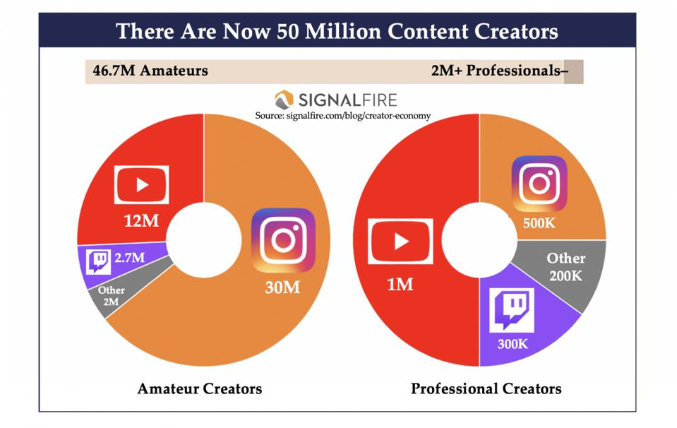

While the current funding ecosystem for creative and artistic talent has evolved in the last few years beyond traditional content monetisation models, current solutions still favour the top minority of creators who have access to an existing audience. Making it no easier for up-and-coming artists with talent to be discovered, let alone get funded.

Some notable examples include:

● On [Spotify](https://www.rollingstone.com/pro/features/spotify-million-artists-royalties-1038408/) (royalties-based content monetisation), the top 43,000 artists — roughly 1.4% of those on the platform — pull in 90% of royalties and make, on average, $22,395 per artist per quarter. The rest of its 3 million creators, or 98.6% of its artists, made just $36 per artist per quarter.

● On YouTube (ad-sharing content monetisation model), [96.5% of creators](https://www.fastcompany.com/40537244/96-5-of-youtube-creators-dont-make-above-the-u-s-poverty-line) don't make enough to reach the U.S. poverty line of $12,140. To compound this issue even further, ad revenue for Creators has declined by 33% during COVID.

● On Patreon (subscription-based fan monetisation), only [2% of creators](https://www.digitalmusicnews.com/2018/01/02/patreon-content-creators-monthly-minimum-wage/) made the federal minimum wage of $1,160 per month in 2017, while the top 15 creators each made over $200,000 per year.

**RepubliK wants to ensure that those people with the talent but not necessarily the resources or existing audiences to make it, don’t miss out on a chance to succeed.**

**----------------------- RepubliK -------------------------**

**INTRODUCTION**

**Welcome to RepubliK. The world’s first digital ecosystem designed to align the interests of creators and supporters.**

RepubliK is a revolutionary ecosystem of digital tools, where talent and their audience can engage with each other in a mutually beneficial way.

This symbiotic relationship of economics **and** trust will redistribute power from legacy platforms and distribution companies into the hands of creators and supporters, enabling better content and more sustainable careers.

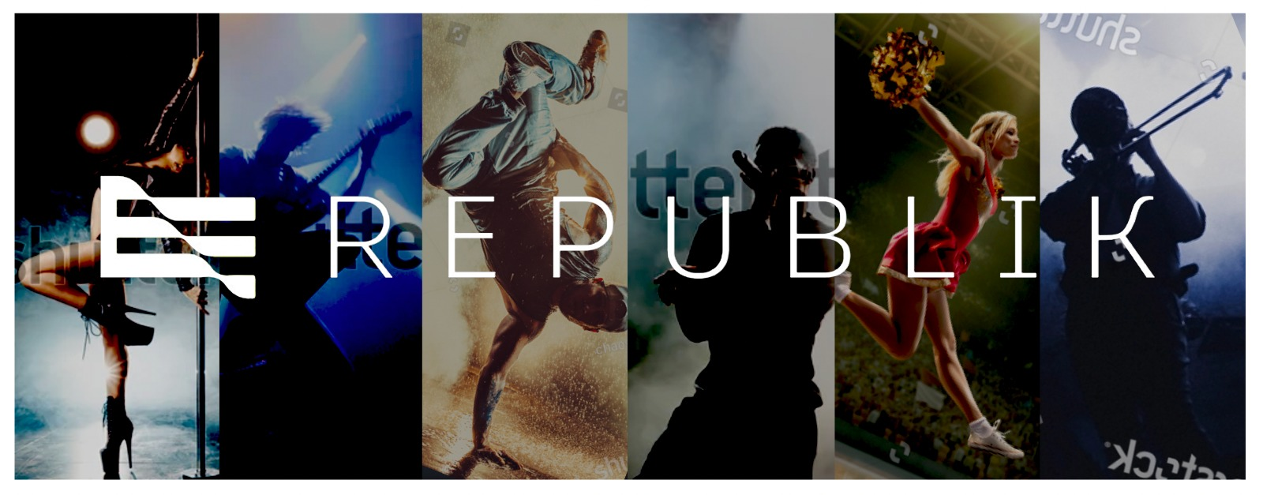

**More than just a smart contract or payment method, the RepubliK ecosystem will encompass:**

1) A transparent and equitable governance system

a) United by a common universal currency that reaches a global audience, with an array of functions that help creators best monetise their work and allows for supporters to participate meaningfully in their success.

2) Exposure and talent discovery

a) An arena that allows multiple streams of continuous head to head competitions that attract, showcase and rank talent. Where the rules of the contest are defined by the creators and not the platform.

3) Virtual performance platform

a) A centralised high capacity network that will be able to scale to large audience sizes numbering in the hundreds of thousands.

b) A second decentralised p2p network for more intimate events with a slate of versatile pricing formats that a creator can utilise for their benefit.

**THE RAD TOKEN**

The current structures limiting creators from reaping the largest benefits and making a living out of their passions are not going to evolve away.

**It’s time for a revolution.**

$RAD will be a secure and transparent base currency built on an EVM compatible smartchain and used to power a number of core functions:

1. Fractionalising future earnings and mass participation in talent investment.
2. Transparent data driven marketplace.
3. Proof of capital/wealth and staking.
4. Platform operations.
5. Rewards and incentives.
6. *Fractionalising future earnings and mass participation in talent investment*

**The Renaissance 2.0.**

As an investor or fan, imagine being able to buy an interest in the future value of any up-and-coming digital creator as easily as you can Like or Share their content. Imagine being able to take a stake in the next global talent phenomena or digital content movement.

As a creator, imagine being able to get a multiple on your earnings when you need it the most instead of just accepting donations or selling content.

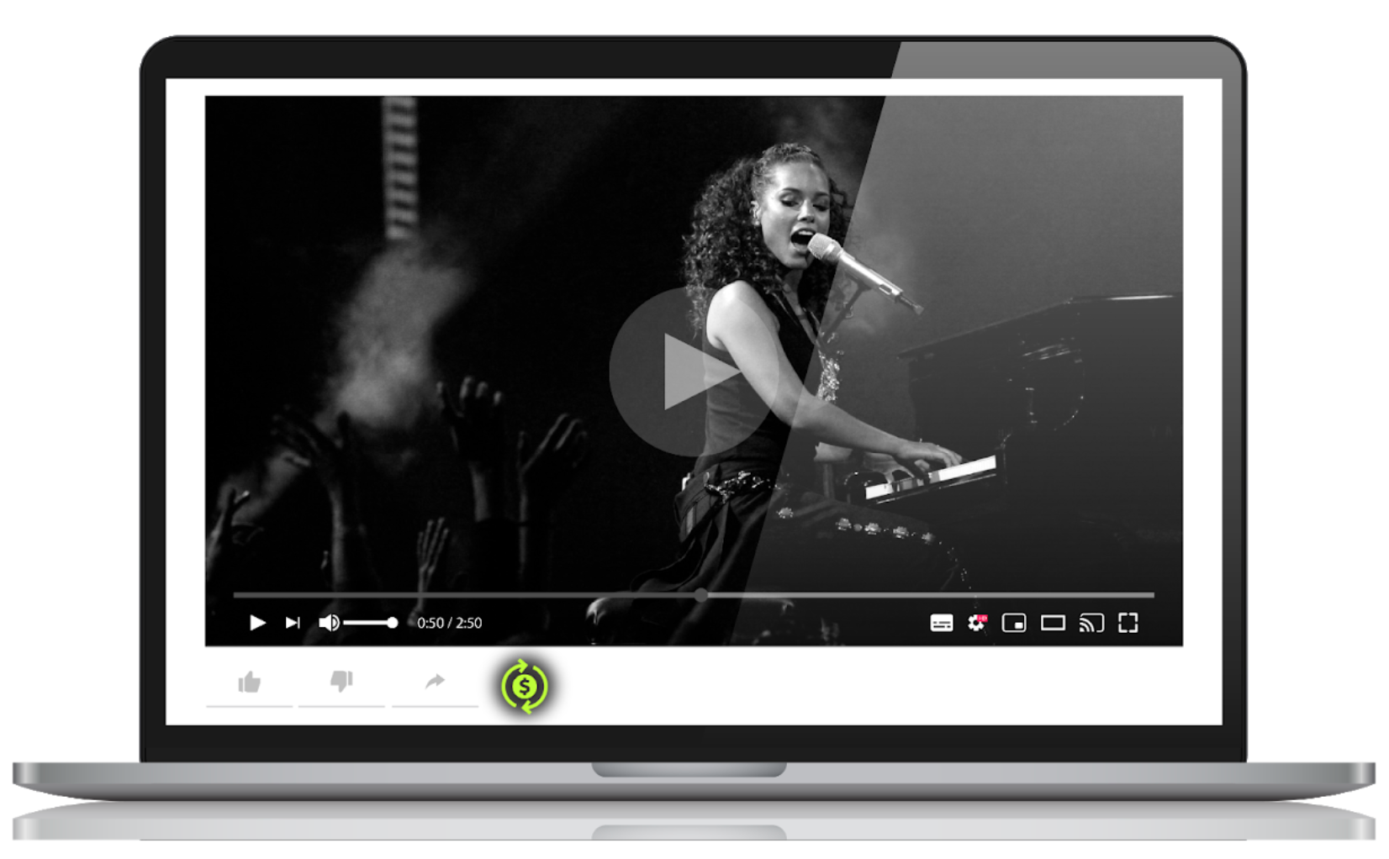

The single largest challenge to mass participation in investing in the creator economy has been the lack of an efficient and secure way to fractionalize contracts for talent across a large number of participants.

Think about the traditional record label model where each creator signs a contract with a label that forms the basis for their relationship. Each contract is lengthy, complex and limited by nature to a few counterparties. No mechanism exists that allows creators to enter into thousands of agreements across hundreds of countries and currencies. The administrative burden would far outweigh the benefits of aggregating multiple small investments.

Smart contracts on the blockchain in the form of SFTs and NFTs are uniquely placed to solve this problem allowing the efficient deployment of any number of smart contracts across a wide range of parameters. We believe that this use case is where the future of NFTs lies and not in the tokenization of content.

**RepubliK will make it easy for creators to create contracts on future earnings**

A simple dashboard is all that a creator needs to interact with. While easy to use, it allows for increasing flexibility and customizability as experience is gained.

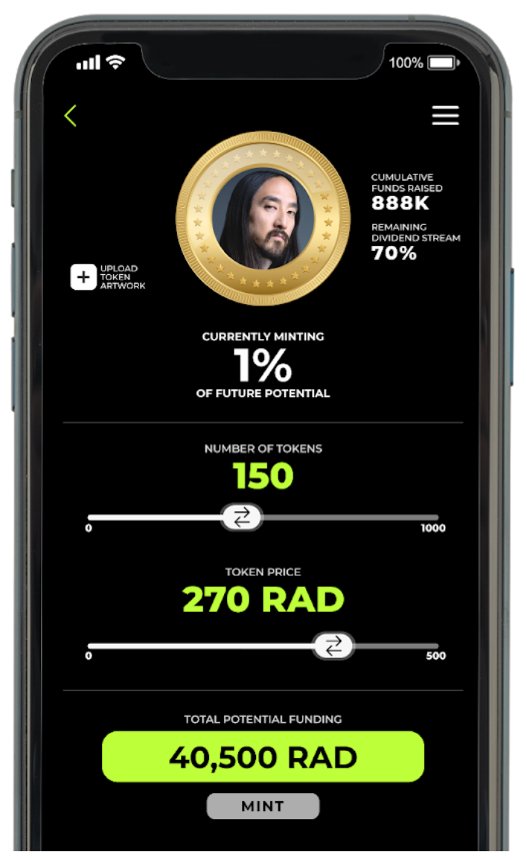

Tokenomics of Creator Tokens:

● $RAD will be required to acquire a Mint and generate creator tokens. The first ~50k mints will be given out free, and a proportion will always continue to be free for deserving creators.

● Each block (representing one percent of the creator’s total on platform potential earnings) is sequentially released after all the tokens minted from the previous block have been sold.

● All revenue generated on platform by creators accrues as dividends distributed to creator tokens.

● Dividends accumulate in creator tokens and can be traded or melted if the owner wants to extract their dividend yield.

● Dividends allocated to tokens still held by the creator in the mint will enter directly into a creator’s $RAD wallet as revenue.

● 3% of blocks representing 3% of future earnings, get donated into the operating platform to fund the operations of the ecosystem.

1. *Transparent data driven marketplace*

**RepubliK provides an intuitive way for the audience to invest and support creators through a transparent, data driven marketplace.**

*Creator data* – each creator’s tokens will be accompanied by a wealth of data that will inform pricing and allow investors and traders to make a value judgement on their purchases.

*Dividend flow* – detailed history of dividend issues, growth and trajectory of each creator.

*Production analytics* – creator ranking, audience size, rate of engagement, number of productions, and more.

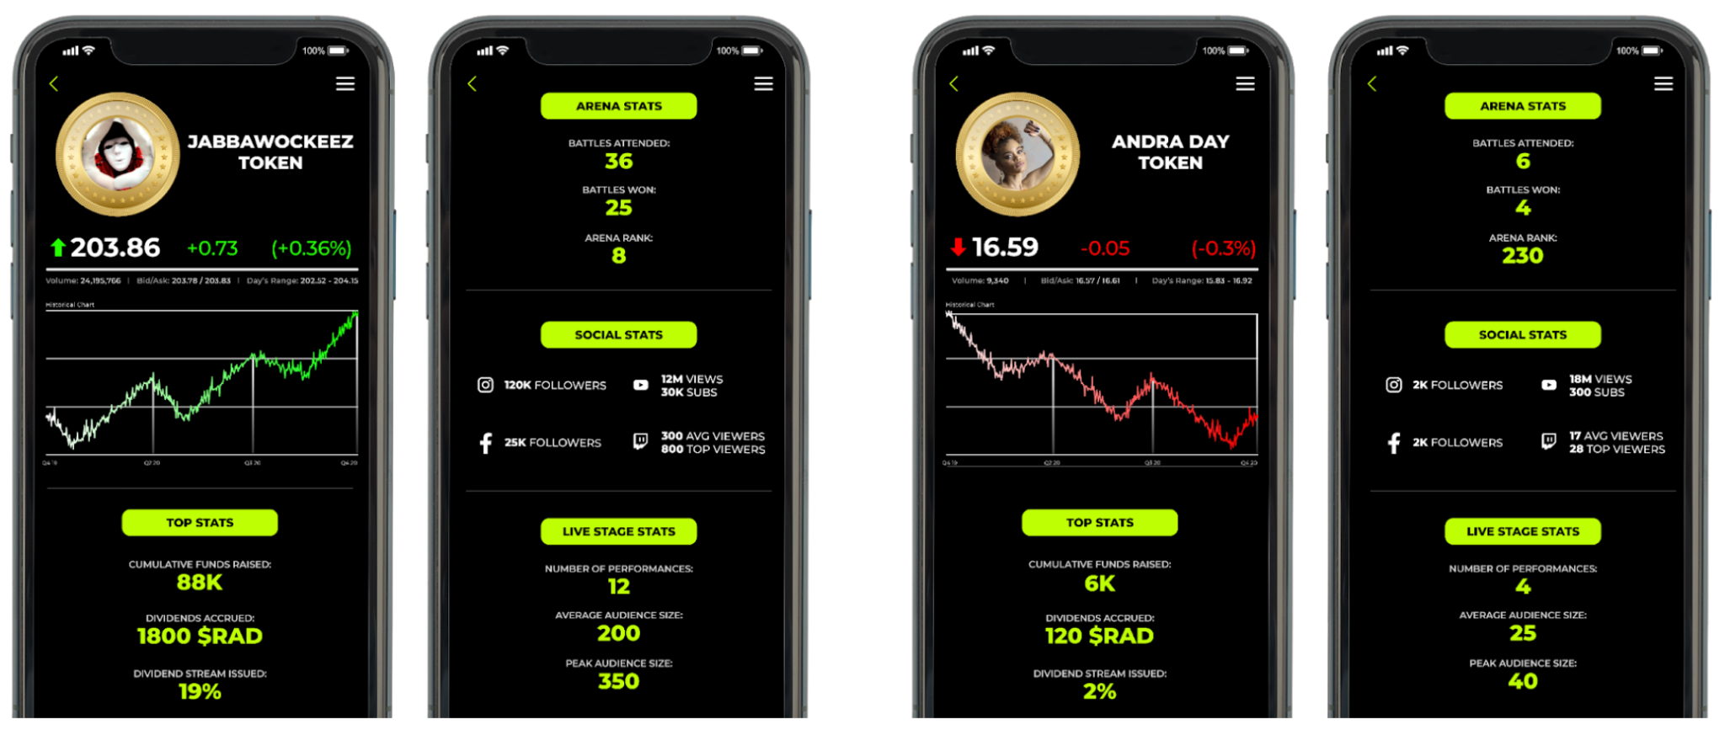

We also envision a lively market for creator tokens of those who have made it to the top of their profession, beyond our ecosystem and on the world stage.

1. *Proof of capital/wealth and Staking*

One of the biggest challenges facing creators in the virtual space is separating true supporters from the background noise of random/fake demands and requests. The normal cues that exist in real world interactions are largely absent or unreliable online.

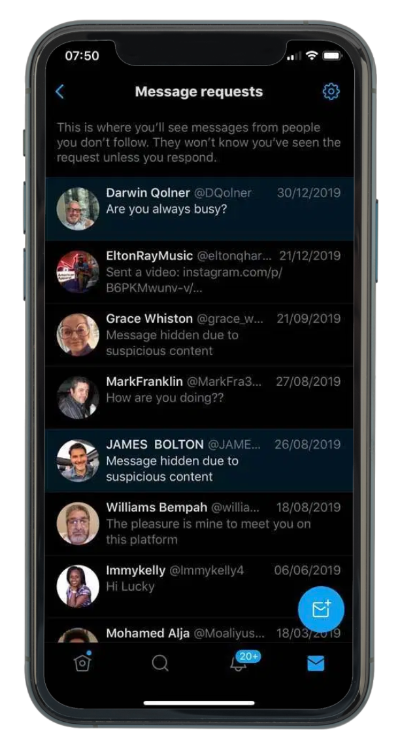

The blockchain architecture of the $RAD economy makes it easy and secure to prove and display your holdings.

As a creator you can see immediately if someone has the capital to invest in you or the ability to pay for your content. As a supporter it’s easy to demonstrate your intent and ability as well as get an insight into artist earnings.

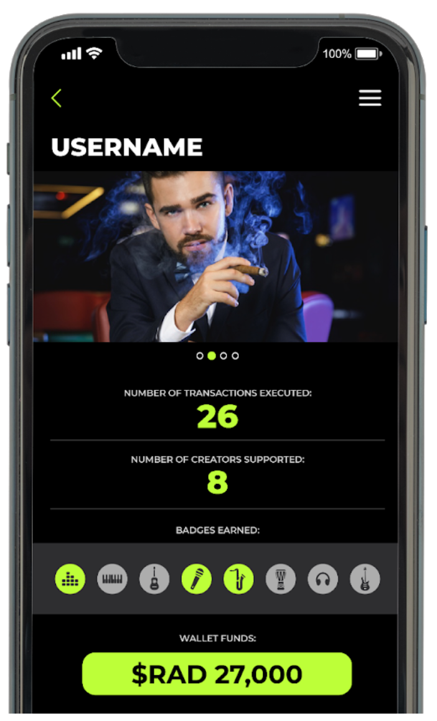

To further strengthen the bond between creators and supporters, supporters will be able to stake on creators. Staking on a creator for a period of time allows the creator to earn an ongoing interest stream from the staked funds. It provides steady income for the creator and allows the supporter to demonstrate his or her intent in a tangible way beyond having to purchase tokens or content.

1. *Operating structure and off platform monetization*

**Platform fees**

The dividend stream from 3% of each creator's tokens pledged to the pool as well as any revenue from the virtual performance platform is paid to the platform. This provides a sustainable funding mechanism for operations within the ecosystem and as a backup for off-platform operating expenses. Any balance will be distributed to All creator token holders, giving back something to participants independent of their creators’ dividend stream.

**Fiat inflows and RAD buy back**

With the amount of ranked content generated, as well as the team's deep experience in brand sponsorship and live events, we believe that there will be very significant avenues for off-platform monetisation.

The platform will drive $fiat monetization opportunities beyond the RepubliK ecosystem in a number of ways:

● The most epic and popular contests from the arena will be automatically turned into side-by-side videos featuring up to 5 creators, optimised for distribution outside of the platform (e.g. YouTube, IG, Facebook, Twitch) to drive both User Acquisition of supporters and performers back to the RepubliK ecosystem, and to generate additional $fiat revenue.

● Development and distribution of content formats that leverage the volume and diversity of our content (showcases, highlight reels, genre-specific compilations, tutorials, etc), supporting marketing efforts and targeting specific audiences & verticals with higher CPMs outside of the RepubliK ecosystem for additional $fiat revenue.

● Ability for brands to discover & support talent through the platform.

● Ability for brands to set up their own bespoke events & activations.

● Sponsored challenges, contests, arenas and stages.

Net $fiat generated off platform will be used to purchase RAD that will be distributed to the creators who generated the monetised content.

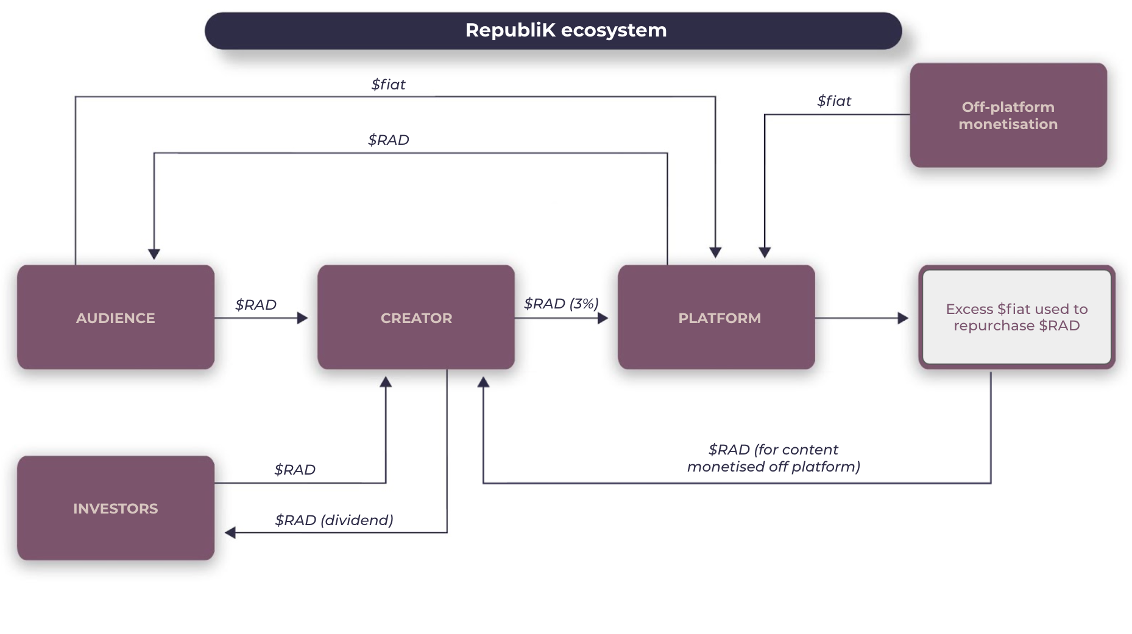

**EXPOSURE AND TALENT DISCOVERY**

Our first practical user-ready participatory feature will be an arena that allows multiple streams of continuous head to head competitions to attract, showcase and rank talent, where the rules of the contest are defined by the creators and not the platform.

Participants will be ranked on a modified ELO ranking system that allows new entrants to go head to head with established creators ensuring that there is no entrenchment of top creators, and newcomers stand a fair chance of being seen and supported.

The arena will turn creator discovery into an entertainment proposition in its own right, gamifying investing into a talent contest experience.

Unlike most content-based platforms which prioritise number of followers (inherently favouring more established creators), the arena takes the battle format and turns it into a venue for mass participation: an infinitely scalable, continuous, iterative talent contest, where the public can vote for and support their favourite performers.

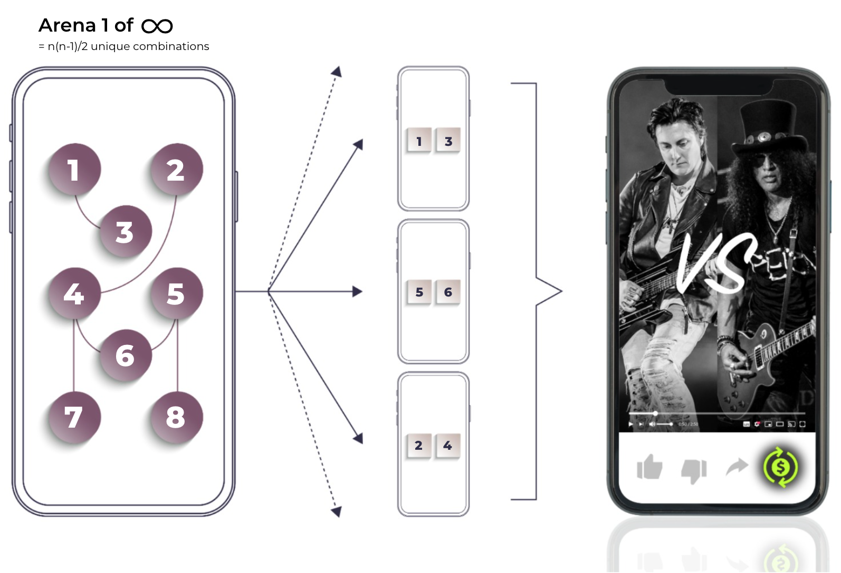

Designed like a casual game: user engagement and rewards

Game mechanics and a reward system designed to maximise continuous engagement on both the creator and supporter side will help drive active usage of the platform:

* Users use $RAD to purchase Creator Tokens, supporting creators financially in the short term and betting on their potential through the promise of dividend payments pegged to their future earnings. By voting for their favourite creator, users help the creator progress up the ranks, earn badges & rewards, get more visibility within the app and, as a result, attract more supporters.
* Everyone (creators & supporters) get rewarded for their active participation on the platform, such as voting, creating or sharing content. These rewards will take the form of:
  + $RAD - $RAD accrues to the users wallet every time they vote in a special event with bonuses for voting on the eventual top contestants. This $RAD can be spent to support talent in the RepubliK.
  + Multipliers - help creators accelerate their earnings by staying more active on the platform and/or can be used to incentivise participation in ‘special events’ taking place in the RepubliK.
  + Badges - social currency to mark milestones in participation that provide holders with governance rights (e.g. selecting new special challenges, voting on contest dynamics), priority access to talent performances, events and one-on-one meets & greets.
* Creators, talent scouts, celebrity-influencers, brands and others will be able to launch contests in arena with their own rules for participation, including:
  + Format, genre, duration, etc
  + Maximum and minimum number of participants (from 1v1 to thousands)
  + Public or Private (by invitation only)
  + Free or paid participation
  + Set game mechanics and rewards: 1v1 and many v many staking with RAD (winner takes all), exclusive access to creators or content, offline rewards, etc.

Some examples of the tens of thousands of contests that will be taking place on RepubliK:

* A creator starts their own series of 1v1 challenges, in which they challenge others to win the total staked. 100 $RAD wager. Winner takes all.
* A dance event launches a competition where the price of entry is 500 $RAD. Top 3 most popular performers each win a % of the prize fund in $RAD.
* A well known footwear brand offers a 10,000 $RAD prize for the most popular skateboarding trick. Winner gets to feature in a commercial for the brand.
* A music megastar runs a public competition in the arena to find its next backing dancers or supporting acts for an upcoming performance. The public decides who the winners are by voting.

**VIRTUAL PERFORMANCE PLATFORM**

RepubliK’s virtual performance platform will be a turnkey, scalable virtual stage system with in-built ticketing, payment, broadcast and promotional capabilities, providing creative and artistic talent with everything they need to showcase and monetise themselves.

It will comprise of two independent networks, each serving different use cases:

a) A centralised high capacity network that will be able to scale to large audience sizes numbering in the hundreds of thousands.

b) A second decentralised p2p network for more intimate events with a slate of versatile pricing formats that a creator can utilise for their benefit.

Fans & supporters use $RAD to purchase access to and perform all transactions within these events, directly supporting the talent and contributing to the dividend pool for Creator Token holders.

RepubliK’s virtual performance platform will enable creators to launch anything from a large scale event featuring one or multiple artists and an audience of thousands (concerts, festivals, talent competitions, casting sessions), an intimate experience for a selected few, a class/course or simply a one-to-one meet & greet to reward super fans/supporters.

Some examples of the possibilities afforded by the virtual performance platform:

* Live Auction with Proof of Wealth
  + Allows creators to run auctions for performances with participants’ staked funds clearly visible to prove legitimacy, as well as built in escrow functions.
* Automated performing rights management
  + Built in licensing and rights agreements with collecting societies for performance.
* Bridge to the physical world
  + Allows creators to run in person performances or classes while still using the RepubliK ecosystem to settle payment and ticketing.
* Private rooms
  + Encrypted and secure p2p connections for performances with an intimate number of participants.
* Multi-creator events with automatic revenue allocation
  + Live will also provide creators with the ability to easily band together to co-host events or shows and to cross promote these to their respective audiences & supporters, with revenue allocation handled directly by the platform.

While initially existing in web and app format, RepubliK will aim to be the performance venue plugin for the various metaverses currently in development.

**CREATOR JOURNEY**

**How RepubliK helps an undiscovered creator along their journey to self-sustenance**

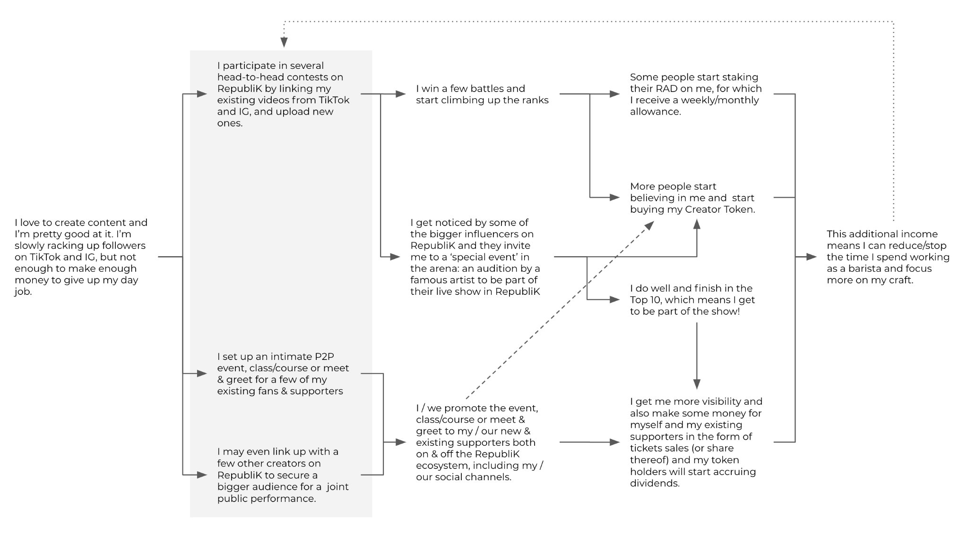

**KEEPING CREATORS ON PLATFORM**

**Keeping creators contributing to the ecosystem, even when they become successful enough to survive on any platform.**

*Paying it forward*

At its core the RepubliK ecosystem is a talent incubator and launchpad for the millions of up-and-coming and undiscovered creators around the world. As young creators become more established, their role within the ecosystem evolves from performer to mentor, helping them pay it forward by promoting emerging creators to get more exposure and funding through the RepubliK ecosystem.

*Low commission fees*

RepubliK only takes 3% of the creators’ dividend stream as commission - the lowest of any artist funding platform - providing even well known creators with large fanbases, a strong incentive to stay within the RepubliK ecosystem and utilise products like Arena, Live Stage and Virtual Store for fan engagement, shows, virtual merchandise sales and more.

*Dividend vs Token value*

We don’t believe that bonding creators to our platform serves any purpose and the greater the success that creators have off platform only proves how effective the RepubliK ecosystem has been in the first place. While we expect creators to continue to utilise the ecosystem for the above reasons and drive dividends for their investors, the dividends make up only a proportion of the worth of their tokens. Other intangibles like popularity and scarcity that drive the existing 100+ billion dollar memorabilia market will be significant contributors.

*Scaling the ecosystem*

Future plans include the development of an API to easily enable any talent or content platform to connect to the RepubliK ecosystem to utilise $RAD, facilitate investment in Creator Tokens through integration of the ‘invest’ button and broaden the opportunities for creators to be discovered and monetise their audiences.

**MARKET ENTRY**

Music and urban dance provide us with an addressable audience that we can cost effectively reach to test & iterate functionality and to generate scale fast.

RepubliK is uniquely placed to address the needs of these audiences. Our core and advisory team includes top executives and influencers from both verticals, providing us with critically important knowledge, credibility and access.

**DISTRIBUTION**

## **Total Supply**

## The total supply of RAD is 3,000,000,000 tokens.

**Token Distribution**

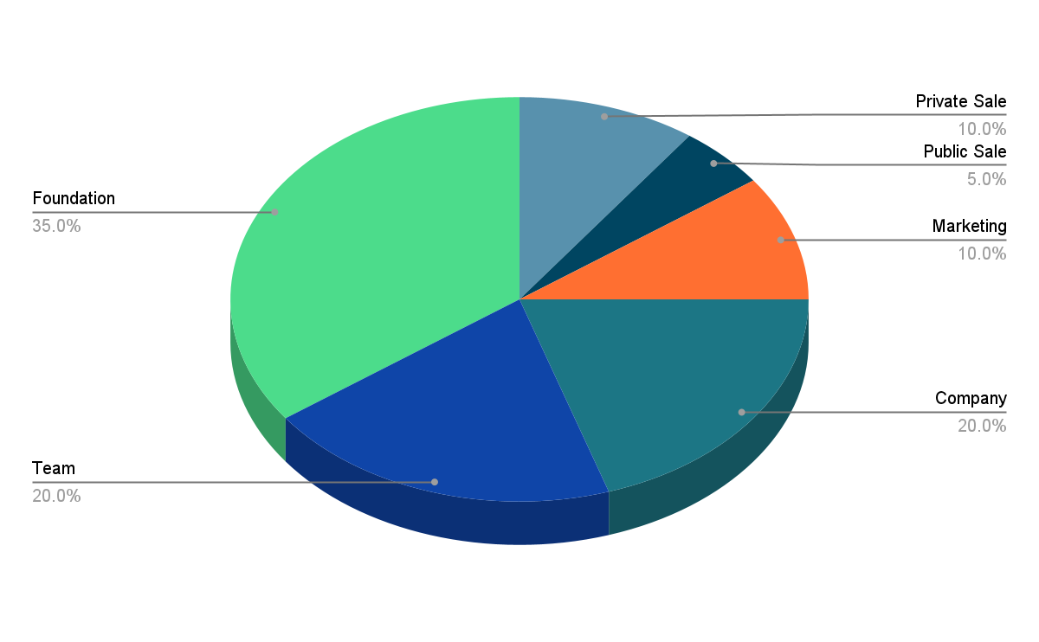

**Private Sale**

The Private Sale consists of 300,000,000 RAD broke into 2 parts:

1. Seed Round  
   5% of total supply  
   150M RAD at USD $0.03  
   Valued at USD $90M fully diluted market cap  
   USD $4.5M raise

1. Early Round  
   5% of total supply  
   150M RAD at USD $0.05  
   Valued at USD $150M fully diluted market cap  
   USD $7.5M raise

**Private Sale Raise:** USD $12M

**Public Sale**

A Public Sale will commence in XXX 2021 through XXX

*Terms*

5% of total supply (150M RAD)

Maximum USD $1000 limit per person

Price per token: USD $0.10

Valued at USD $300M fully diluted market cap

**Public Raise Amount:** USD $15M

**‍**

**RELEASE SCHEDULE**

*Private Sale*

The private sale release schedule is as follows:

● ‍Month 3 (Jul 30, 2021): 10%

● ‍Month 6 (Oct 28, 2021): 15%

● ‍Month 9 (Jan 26, 2022): 15%

● ‍Month 12 (Apr 26, 2022): 15%

● ‍Month 15 (Jul 25, 2022): 15%

● ‍Month 18 (Oct 23, 2022): 15%

● Month 21 (Jan 21, 2023): 15%

*Public Sale*

Linear vesting until 100% unlocked at the end of the vesting period.

● Total vesting period: 12 months

● ‍Vesting begins: 30 days after Public Sale closing date

**Company & Marketing**

3% initial release the rest monthly vesting over 5 years with milestone accelerations.

**Team**

5% initial release the rest over 3 years

**Foundation**

5% initial release the rest monthly over 5 years

**----------------------- Team -------------------------**

**CORE TEAM**

- **David Webster - *CEO***, formerly Chief Commercial Officer of gaming company yup.gg and Chief Growth Officer & Managing Director of advertising agency BBH Asia Pacific developing regional & global campaigns for brands including Nike, RedBull, Netflix, Uber, Google and Facebook among others. ([LinkedIn](https://www.linkedin.com/in/david-webster-aba90219/))

- **Daniel He - *CFO****,* Co-founder The Lo&Behold Group, Economics advisor ( Enjin) Physician and Director (Philanthropy) Emergency Medicine Academic Clinical Programme (Singhealth), President Multi-Rotor Association Singapore, former consultant at Monitor Group Asia.

- **Ben Dickenson *- VP Product***, currently Product Owner at free-to-play mobile game developer Huuuge Games and former Director of Product Management at Australia’s largest indie game developer Mighty Kingdom, where he led the design and development of 23 published mobile games and apps. ([LinkedIn](https://www.linkedin.com/in/bendickenson/))

- **Felix Huang - *VP Community****,* Founder & Managing Director of Recognize Studios, Founder of Radikal Forze Jam Hip-Hop Festival, Co-founder of Jam Republic.Felix is a veteran of the Asian and Global urban dance scene. As the leader of Singapore’s pioneering breakin’ dance group, Radikal Forze, he created and ran one of the largest and most culturally significant urban dance events in the world for the past 10 years. Regularly attracting thousands of dance tourists from over 40 countries to Singapore every year, including some of the world's most renowned performers, trendsetters, and up and coming global stars within the dance community. Felix is also co-founder of Jam Republic - one of the world’s largest networks of dance studios - and is owner of Recognize Studios, Singapore’s #1 urban dance studio.

- **Jonathan Nah - *Creative Director***, AKA Kiat, Jonathan has been at the forefront of the Asian creative scene as a designer, DJ, music producer and contemporary artist. ([Website](https://www.jonathanah.com/interviews))

**ADVISORS**

- **Richmond Teo (Lead Advisor)**, Richmond Teo is the CEO of Asia and a co-founder of Paxos. With more than a decade of experience analyzing and investing in public and private financial technology companies, Rich has a strong understanding of market structure, stock and commodity exchanges and clearing corporations. Prior to Paxos, he served as a Principal at Cedar Hill Capital Partners, overseeing the firm’s investments across the capital structure of various financial services institutions. He was also a Financial Analyst at Citi where he worked on mergers and acquisitions involving exchanges, trading technology, banks and brokers.

- **Simon Pestridge**, former Nike VP Marketing for UK/Ireland and Greater China. ([LinkedIn](https://www.linkedin.com/in/simon-j-pestridge-b6437552/))

- **Tim Zhu**, currently senior technical program manager at Uber, former co-founder and CTO at multiple startups. ([LinkedIn](https://www.linkedin.com/in/tim-zhu/))

- **Carl Norberg**, founder of Turnpike Group and serial media entrepreneur with multiple exits. ([LinkedIn](https://www.linkedin.com/in/carlnorberg/))

**- Mari Koda,** A dance actress who played the main female dance lead in step up 2, step up 3d, step up 4: miami heat, and step up all in movie series. She spends her free time coaching up up orphanages, juvenile correctional facilities & youth-at-risks in different countries around asia. She has worked with artists like jamie foxx, black eyed peas, Big daddy Kane, Timbaland, 50cent, Large Pro, Marley Marl, DJ Scratch, Evil Dee, Craig G, Patti Labelle, cascada

- **Kantaro Charisma.** Founder&CEO of Anomaly inc.<https://anomaly.co.jp>, COO of D.LEAGUE inc.<https://www.dleague.co.jp>, Director of expg inc.<https://expg.jp>, President of FIDA Japan<http://fidajapan.com>

- **Mike Song,** co-founder and co-owner of Kinjaz. Currently the world’s most respected urban choreography dance group which has studios located in Los Angeles, shanghai, beijing, and chengdu. Choreographed and worked with , jacksong wang, Lu Han, DK from IKON, Hoony from Winner, Treasure 13, Cirque de soleil , Chainsmokers, troyboi.